Mathematics Methods Unit 1 (2018)
Name: _____________________________

Test 2B
Topic 2: Trigonometric Functions and Equations
Total time allowed: 37 minutes. Total marks: 33 marks
Section One:
Calculator-free
Time allowed for this section: 17 minutes
Total marks for this section: 15 marks
Materials required for this section:
SCSA Formula Sheet

Instructions to candidates
Show all your working clearly. Your working should be in sufficient detail to allow your answers to be checked readily and for marks to be awarded for reasoning. Incorrect answers given without supporting reasoning cannot be allocated any marks. For any question or part question worth more than two marks, valid working or justification is required to receive full marks. If you repeat any question, ensure that you cancel the answer you do not wish to have marked.

Question 1 | [2 marks]

Show that $\sin\left(x+\frac{π}{2}\right)=\cos{x}$ using an angle sum identity.

Question 2 | [3, 3, 3 = 9 marks]

Solve the following equations.

a) $\sqrt{3}\tan{x}+1=0$ where $-π≤x≤π$

b) $\cos\left(2x\right)=\frac{\sqrt{3}}{2}$ where $0≤x≤2π$

c) $2\sin{x}\cos{40°-2\cos{x\sin{40°=-1}}}$ where $0°≤x≤360°$

Question 3 | [4 marks]

The graphs of $y=\sin{(bx)}$ , $y=b\cos\left(cx\right)$ and $y=\tan{(x+d)}$, are given below.
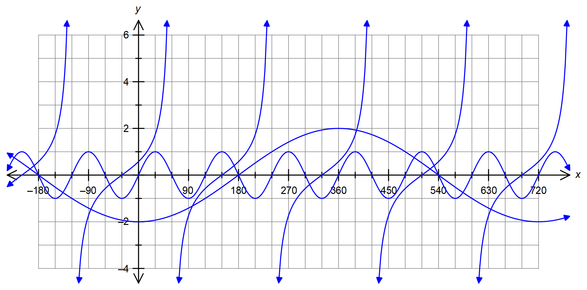

Determine the values of $a, b, c$ and $d$.

Mathematics Methods Unit 1 (2018)
Name: _____________________________

Test 2B
Topic 2: Trigonometric Functions and Equations
Section Two:
Calculator-assumed
Time allowed for this section: 20 minutes
Total marks for this section: 18 marks
Materials required/recommended for this section:
SCSA Formula Sheet
Notes on one sheet (both sides) of A4 paper
Up to three approved calculators

Instructions to candidates
Show all your working clearly. Your working should be in sufficient detail to allow your answers to be checked readily and for marks to be awarded for reasoning. Incorrect answers given without supporting reasoning cannot be allocated any marks. For any question or part question worth more than two marks, valid working or justification is required to receive full marks. If you repeat any question, ensure that you cancel the answer you do not wish to have marked.

Question 4 | [4 marks]

Angles A and B are both obtuse angles such that $\sin{A}=\frac{8}{17}$ and $\tan{B}=-\frac{2}{3}$.

Determine the exact value for $\sin{(A+B)}$

Question 5 | [4, 2 = 6 marks]

a) Show that $\cos{(-75°)}=\frac{\sqrt{2}\left(\sqrt{3}-1\right)}{4}$.

b) Hence or otherwise, solve $2\sqrt{2}\cos{x}=\sqrt{3}-1$ where $-90°≤x≤360$

Question 6 | [1, 4, 1, 2 = 8 marks]

The height above the ground of a carriage on the circumference of large Ferris wheel is given by the following function.

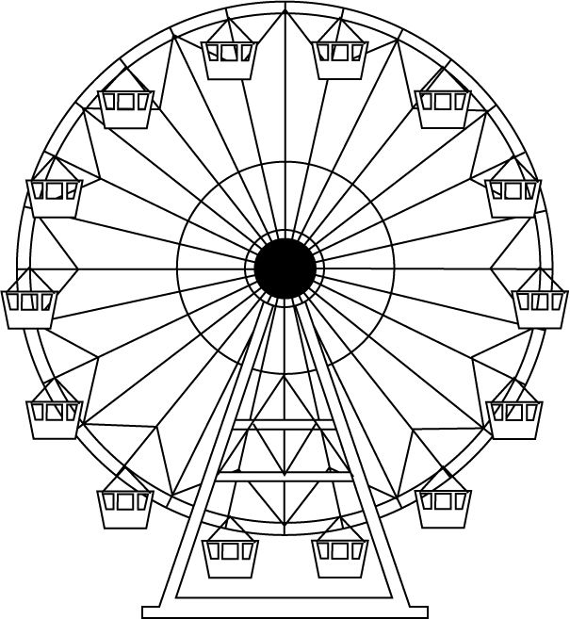
$h(t)=25\sin\left(\frac{π t}{8}-\frac{π}{2}\right)+30$

Where the height $h$ is in metres and the time $t$ is in minutes.

a) Determine the height of the carriage above the ground when $t=4$.

b) Sketch the graph of $h(t)$ on the axes below for $0≤t≤28$.

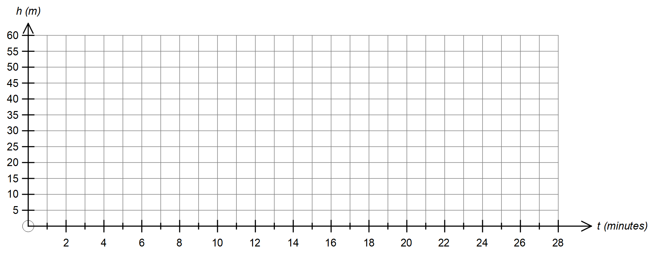

c) How long does the Ferris wheel take to rotate once?

d) The view from the Ferris wheel carriage is uninterrupted (best) when the height of the carriage is at least 36 metres
above the ground. For how long does the carriage enjoy uninterrupted views if the Ferris wheel rotates twice.

Mathematics Methods Unit 1 (2018)
Name: ___SOLUTIONS________

Test 2B
Topic 2: Trigonometric Functions and Equations
Total time allowed: 37 minutes. Total marks: 33 marks
Section One:
Calculator-free
Time allowed for this section: 17 minutes
Total marks for this section: 15 marks
Materials required for this section:
SCSA Formula Sheet

Instructions to candidates
Show all your working clearly. Your working should be in sufficient detail to allow your answers to be checked readily and for marks to be awarded for reasoning. Incorrect answers given without supporting reasoning cannot be allocated any marks. For any question or part question worth more than two marks, valid working or justification is required to receive full marks. If you repeat any question, ensure that you cancel the answer you do not wish to have marked.

Question 1 | [2 marks]

Show that $\sin\left(x+\frac{π}{2}\right)=\cos{x}$ using an angle sum identity.

$\sin\left(x+\frac{π}{2}\right)=\sin{x}\cos{\frac{π}{2}}+\cos{x}\sin{\frac{π}{2}}$ uses correct angle sum identity

$=\sin{x}\left(0\right)+\cos{x}(1)$ simplifies to show that which is required

$=\cos{x}$

Question 2 | [3, 3, 3 = 9 marks]

Solve the following equations.

a) $\sqrt{3}\tan{x}+1=0$ where $-π≤x≤π$

$\tan{x=-\frac{1}{\sqrt{3}}}$ rearranges equation

$∴x=\frac{- π}{6} , \frac{5π}{6}$ two solutions in correct domain

b) $\cos\left(2x\right)=\frac{\sqrt{3}}{2}$ where $0≤x≤2π$

Solving for $2x$ over the domain $0≤2x≤4π$

$2x{=\frac{π}{6} }, \frac{11π}{6} , \frac{13π}{6} , \frac{23π}{6}$ where $0≤2x≤\frac{24π}{6}$

obtains two correct solutions for $2x$
solves for $2x$ over $0≤2x≤4π$ to obtain all four correct solutions

$∴x{=\frac{π}{12} }, \frac{11π}{12} , \frac{13π}{12} , \frac{23π}{12}$

solves for $x$ by dividing by 2

c) $2\sin{x}\cos{40°-2\cos{x\sin{40°=-1}}}$ where $0°≤x≤360°$

$\sin{x}\cos{40°-\cos{x\sin{40°=-\frac{1}{2}}}}$

$\sin{(x-40°)}=-\frac{1}{2}$ uses angle difference identity

Solving for $x-40°$ over the domain $-40°≤x-40°≤320°$

$x-40°=-30°, 210°$ solves for $x-40°$ between – 40° and 320°

$x=10° , 250°$ solves for x solution by adding 40°

Question 3 | [4 marks]

The graphs of $y=\sin{(bx)}$ , $y=b\cos\left(cx\right)$ and $y=\tan{(x+d)}$, are given below.


Determine the values of $a, b, c$ and $d$.

$a=3$

$b=-2$

$c=\frac{1}{2}$

$d=30$

Mathematics Methods Unit 1 (2018)
Name: ___SOLUTIONS________

Test 2B
Topic 2: Trigonometric Functions and Equations
Section Two:
Calculator-assumed
Time allowed for this section: 20 minutes
Total marks for this section: 18 marks
Materials required/recommended for this section:
SCSA Formula Sheet
Notes on one sheet (both sides) of A4 paper
Up to three approved calculators

Instructions to candidates
Show all your working clearly. Your working should be in sufficient detail to allow your answers to be checked readily and for marks to be awarded for reasoning. Incorrect answers given without supporting reasoning cannot be allocated any marks. For any question or part question worth more than two marks, valid working or justification is required to receive full marks. If you repeat any question, ensure that you cancel the answer you do not wish to have marked.

Question 4 | [4 marks]

Angles A and B are both obtuse angles such that $\sin{A}=\frac{8}{17}$ and $\tan{B}=-\frac{2}{3}$.

Determine the exact value for $\sin{(A+B)}$
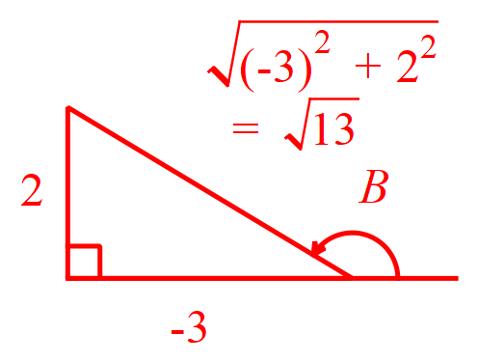

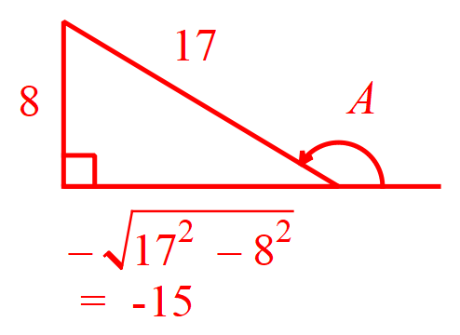

$\cos{A}=-\frac{15}{17}$ $\sin{B}=\frac{2}{\sqrt{13}}$

$\cos{B}=-\frac{3}{\sqrt{13}}$

$\sin{(A+B)}=\sin{A}\cos{B}+\cos{A}\sin{B}$
uses angle sum identity

$=\frac{8}{17}×\frac{-3}{\sqrt{13}}+\frac{-15}{17}×\frac{2}{\sqrt{13}}$ determines exact value for $\cos{A}$
determines exact values for $\sin{B}$ and $\cos{B}$
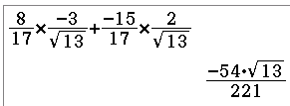
$=\frac{-24}{17\sqrt{13}}+\frac{-30}{17\sqrt{13}}$

$=\frac{-54}{17\sqrt{13}}=\frac{-54\sqrt{13}}{221}$ determines exact value
required

Question 5 | [4, 2 = 6 marks]

a) Show that $\cos{(-75°)}=\frac{\sqrt{2}\left(\sqrt{3}-1\right)}{4}$.

$\cos{(-75°)}=\cos{(-45°-30°)}$ shows -75° as -45° – 30°

$=\cos\left(-45°\right)\cos\left(30°\right)+\sin\left(-45°\right)\sin\left(30°\right)$ uses angle difference identity

$=\frac{\sqrt{2}}{2}×\frac{\sqrt{3}}{2}+\frac{-\sqrt{2}}{2}×\frac{1}{2}$ uses exact values for sin, cos -45° and 30°

$=\frac{\sqrt{2}\sqrt{3}-\sqrt{2}}{4}$

$=\frac{\sqrt{2}\left(\sqrt{3}-1\right)}{4}$ simplifies and factorises to show that which is required

b) Hence or otherwise, solve $2\sqrt{2}\cos{x}=\sqrt{3}-1$ where $-90°≤x≤360$

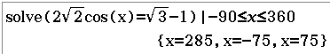
$\cos{x}=\frac{\sqrt{3}-1}{2\sqrt{2}}$

$\cos{x}=\frac{\sqrt{2}\left(\sqrt{3}-1\right)}{2\sqrt{2}\sqrt{2}}=\frac{\sqrt{2}\left(\sqrt{3}-1\right)}{4}$ (no mark) rearranges equation or uses CAS to solve

$x=-75° , 75° , 285°$ one correct solution all three correct solutions

Question 6 | [1, 4, 1, 2 = 8 marks]

The height above the ground of a carriage on the circumference of large Ferris wheel is given by the following function.


$h(t)=25\sin\left(\frac{π t}{8}-\frac{π}{2}\right)+30$

Where the height $h$ is in metres and the time $t$ is in minutes.

a) Determine the height of the carriage above the ground when $t=4$.

$h=25\sin\left(\frac{π 4}{8}-\frac{π}{2}\right)+30$

$h=25\sin\left(0\right)+30$

$h=30$ metres correct height

b) Sketch the graph of $h(t)$ on the axes below for $0≤t≤28$.

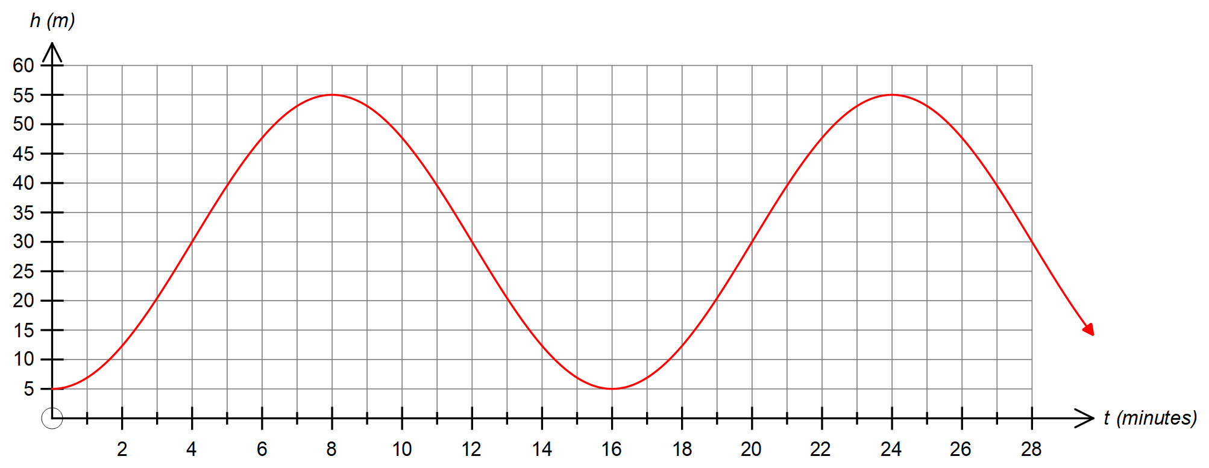

$h(4)=h(12)=h(20)=h(28)=30$ minimums at (0, 5) and (16, 5)
maximums at (8, 55) and (24, 55) smooth curve through above points, no abrupt ‘corners’

c) How long does the Ferris wheel take to rotate once?

16 minutes correct time

d) The view from the Ferris wheel carriage is uninterrupted (best) when the height of the carriage is at least 36 metres
above the ground. For how long does the carriage enjoy uninterrupted views if the Ferris wheel rotates twice.

Solve $25\sin\left(\frac{π t}{8}-\frac{π}{2}\right)+30=36$

CAS $t=4.6172 , 11.3828$ solves for height of 36 metres

Time spent at least 36 metres above the ground $=2×\left(11.3828-4.6172\right)≈13.5$ minutes

determines time in minutes to at least 1 d.p. rounding down.

